**NAME:PRANAV SANDEEP RAIKAR**

**D15A 47**

# EXP 8

**Aim**: To code and register a service worker, and complete the install and activation process for a new service worker for a PWA

**Theory**:

**Service Worker**

Service Worker is a script that works on browser background without user interaction independently. Also, It resembles a proxy that works on the user side. With this script, you can track network traffic of the page, manage push notifications and develop “offline first” web applications with Cache API.

Things to note about Service Worker:

* A service worker is a programmable network proxy that lets you control how network requests from your page are handled.
* Service workers only run over HTTPS. Because service workers can intercept network requests and modify responses, "man-in-the-middle" attacks could be very bad.
* The service worker becomes idle when not in use and restarts when it's next needed. You cannot rely on a global state persisting between events. If there is information that you need to persist and reuse across restarts, you can use IndexedDB databases.

**What can we do with Service Workers?**

* You can dominate **Network Traffic**

You can manage all network traffic of the page and do any manipulations. For example, when the page requests a CSS file, you can send plain text as a response or when the page requests an HTML file, you can send a png file as a response. You can also send a true response too.

* You can **Cache**

You can cache any request/response pair with Service Worker and Cache API and you can access these offline content anytime.

* You can manage **Push Notifications**

You can manage push notifications with Service Worker and show any information message to the user.

* You can **Continue**

Although Internet connection is broken, you can start any process with Background Sync of Service Worker.

**What can’t we do with Service Workers?**

* You can’t access the **Window**

You can’t access the window, therefore, You can’t manipulate DOM elements. But, you can communicate to the window through post Message and manage processes that you want.

* You can’t work it on **80 Port**

Service Worker just can work on HTTPS protocol. But you can work on localhost during development.

**Service Worker Cycle**

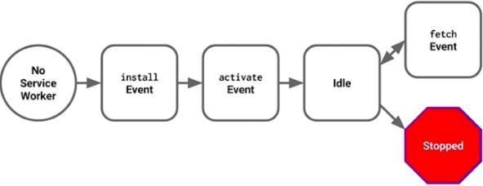

A service worker goes through three steps in its life cycle:

* Registration
* Installation
* Activation

My Project’s folder structure:

**Registration**

To install a service worker, you need to register it in your main JavaScript code. Registration tells the browser where your service worker is located, and to start installing it in the background.

**CODE:**

public/index.html

<!DOCTYPE html>

<html lang="en">

<head>

<meta charset="utf-8" />

<link rel="icon" href="%PUBLIC_URL%/favicon.ico" />

<meta name="viewport" content="width=device-width, initial-scale=1" />

<meta name="theme-color" content="#000000" />

<meta

name="description"

content="Web site created using create-react-app"

/>

<link rel="apple-touch-icon" href="%PUBLIC_URL%/logo192.png" />

<!--

manifest.json provides metadata used when your web app is installed on a

user's mobile device or desktop. See https://developers.google.com/web/fundamentals/web-app-manifest/

-->

<link rel="manifest" href="%PUBLIC_URL%/manifest.json" />

<!--

Notice the use of %PUBLIC_URL% in the tags above.

It will be replaced with the URL of the `public` folder during the build.

Only files inside the `public` folder can be referenced from the HTML.

Unlike "/favicon.ico" or "favicon.ico", "%PUBLIC_URL%/favicon.ico" will

work correctly both with client-side routing and a non-root public URL.

Learn how to configure a non-root public URL by running `npm run build`.

-->

<title>Pranav's To do list</title>

</head>

<body>

<noscript>You need to enable JavaScript to run this app.</noscript>

<div id="root"></div>

<!--

This HTML file is a template.

If you open it directly in the browser, you will see an empty page.

You can add webfonts, meta tags, or analytics to this file.

The build step will place the bundled scripts into the <body> tag.

To begin the development, run `npm start` or `yarn start`.

To create a production bundle, use `npm run build` or `yarn build`.

-->

<script>

window.addEventListener("load", () => {

registerSW();

});

// Register the Service Worker

async function registerSW() {

if ("serviceWorker" in navigator) {

try {

await navigator.serviceWorker.register("serviceworker.js");

} catch (e) {

console.log("SW registration failed");

}

}

}

</script>

</body>

</html>

**Installation**

Once the browser registers a service worker, installation can be attempted. This occurs if the service worker is considered to be new by the browser, either because the site currently doesn't have a registered service worker, or because there is a byte difference between the new service worker and the previously installed one.

A service worker installation triggers an install event in the installing service worker. We can include an install event listener in the service worker to perform some task when the service worker installs. For instance, during the install, service workers can precache parts of a web app so that it loads instantly the next time a user opens it (see caching the application shell). So, after that first load, you're going to benefit from instant repeat loads and your time to interactivity is going to be even better in those cases. An example of an installation event listener looks like this:

**self.addEventListener("install", function (e) {**

**e.waitUntil(**

**caches.open(staticCacheName).then(function (cache) {**

**return cache.addAll(["/"]);**

**})**

**);**

**});**

*~This is done in serviceworker.js*

**Activation**

Once a service worker has successfully installed, it transitions into the activation stage. If there are any open pages controlled by the previous service worker, the new service worker enters a waiting state. The new service worker only activates when there are no longer any pages loaded that are still using the old service worker. This ensures that only one version of the service worker is running at any given time.

When the new service worker activates, an activate event is triggered in the activating service worker. This event listener is a good place to clean up outdated caches.

**self.addEventListener('activate', event => { event.waitUntil(**

**caches.keys().then(cacheNames => {**

**return Promise.all(**

**cacheNames.filter(name => {**

**return name !== staticCacheName;**

**}).map(name => { return caches.delete(name);**

**})**

**);**

**})**

**);**

**});**

*~This is done in serviceworker.js*

Therefore, serviceworker.js finally looks like this:

**var staticCacheName = "pwa";**

**self.addEventListener("install", function (e) {**

**e.waitUntil(**

**caches.open(staticCacheName).then(function (cache) {**

**return cache.addAll(["/"]);**

**})**

**);**

**});**

**self.addEventListener('activate', event => { event.waitUntil(**

**caches.keys().then(cacheNames => { return Promise.all(**

**cacheNames.filter(name => {**

# return name !== staticCacheName;

**}).map(name => { return caches.delete(name);**

**})**

**);**

**})**

**);**

**});**

**self.addEventListener("fetch", function (event) {**

**console.log(event.request.url);**

**event.respondWith(**

**caches.match(event.request).then(function (response) {**

**return response || fetch(event.request);**

**})**

**);**

**});**

We now run the app using the following command:

> npm run start

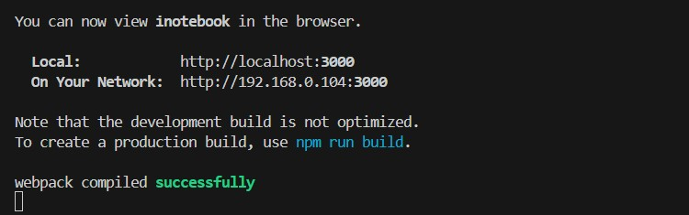

On the browser:

**Conclusion:**

The aim was to implement a service worker for a Progressive Web Application (PWA), enabling offline functionality and improving performance. This involved coding and registering the service worker (serviceworker.js) to intercept network requests, cache essential resources, and enhance the offline experience. By completing the install and activation process, the PWA gained features like offline access and faster page loads, enhancing user experience and resilience to network issues.